Market Monitor - Somalia - 2026-05

Highlights
Food prices rose sharply across Somalia in May 2026, accelerating an inflationary trend and putting pressure on household purchasing power. The cost of the food basket increased by 6.9% month-on-month and 22.1% year-on-year.
The increase was led by significant price hikes for imported rice (↑11.4% MoM; ↑37.8% YoY), cowpeas (↑8.9% MoM; ↑30.0% YoY), and white sorghum (↑7.7% MoM; ↑14.3% YoY).
Key drivers of inflation include:
- Widespread monthly price increases across all food basket commodities, led by key staples such as imported rice (↑11.4%) and cowpeas (↑8.9%).
- High inflation in the livestock sector, with live goat prices surging 26.7% month-on-month and 79.8% year-on-year.
- Sustained high operational costs, as diesel prices remained 48.3% higher than the previous year, increasing the cost of transportation and production.
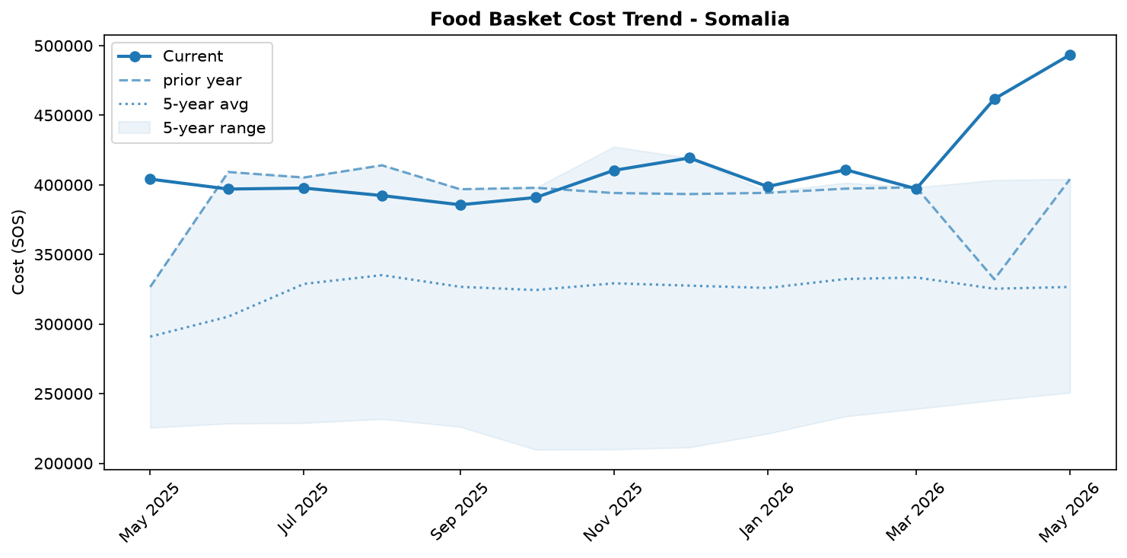
Food basket cost trend

Market Overview
Market conditions in Somalia deteriorated significantly in May 2026, characterized by accelerating and widespread inflation that is severely straining household purchasing power. The national average cost of the food basket surged by 6.9 percent month-on-month and a staggering 22.1 percent year-on-year, indicating persistent and broad-based price pressures. This inflationary trend was primarily driven by sharp increases in the cost of key staples, particularly imported rice, and a dramatic surge in livestock prices. While monthly fuel prices remained stable, the high year-on-year cost of diesel (+48.3 percent) continues to embed elevated transport and production costs throughout the economy, contributing to the annual inflation across all sectors.
These market dynamics unfold against a complex and concerning humanitarian backdrop. While one report noted improvements in household food consumption scores, this is starkly contrasted by more recent alerts of rapidly worsening food insecurity, a credible risk of famine in areas like Burhakaba District, and a significant rise in admissions of severely malnourished children to stabilization centers. The country's ranking as the world's most fragile state underscores the systemic challenges—including conflict and climate shocks—that exacerbate market volatility and hinder effective humanitarian and economic responses, placing vulnerable populations at increasing risk.

Commodity Analysis
A detailed analysis of key commodities reveals the drivers behind May's sharp inflationary pressures. The overall food basket's 6.9 percent monthly price hike was led by imported staples, with rice prices jumping 11.4 percent in one month and 37.8 percent over the year. This significant increase, occurring despite a stable Somali Shilling, points to rising international commodity prices or severe logistical constraints impacting import supply chains.
The livestock sector, central to Somalia's economy and exports, experienced extreme price inflation. The price for a live goat surged by an exceptional 26.7 percent month-on-month, reaching a level 79.8 percent higher than the previous year. This has a dual effect: while potentially increasing incomes for some pastoralists, it directly fuels food inflation for consumers, with goat meat prices rising 14.4 percent. This trend threatens to reduce household access to essential animal-source proteins, a finding consistent with reports of rising child malnutrition.
Underpinning these trends is the persistently high cost of energy. Although diesel prices were stable month-on-month, the 48.3 percent year-on-year increase has established a high-cost environment for transportation. This elevated cost base is a critical factor contributing to the widespread annual inflation observed across both food and non-food items, amplifying the impact of other price shocks throughout the domestic market.
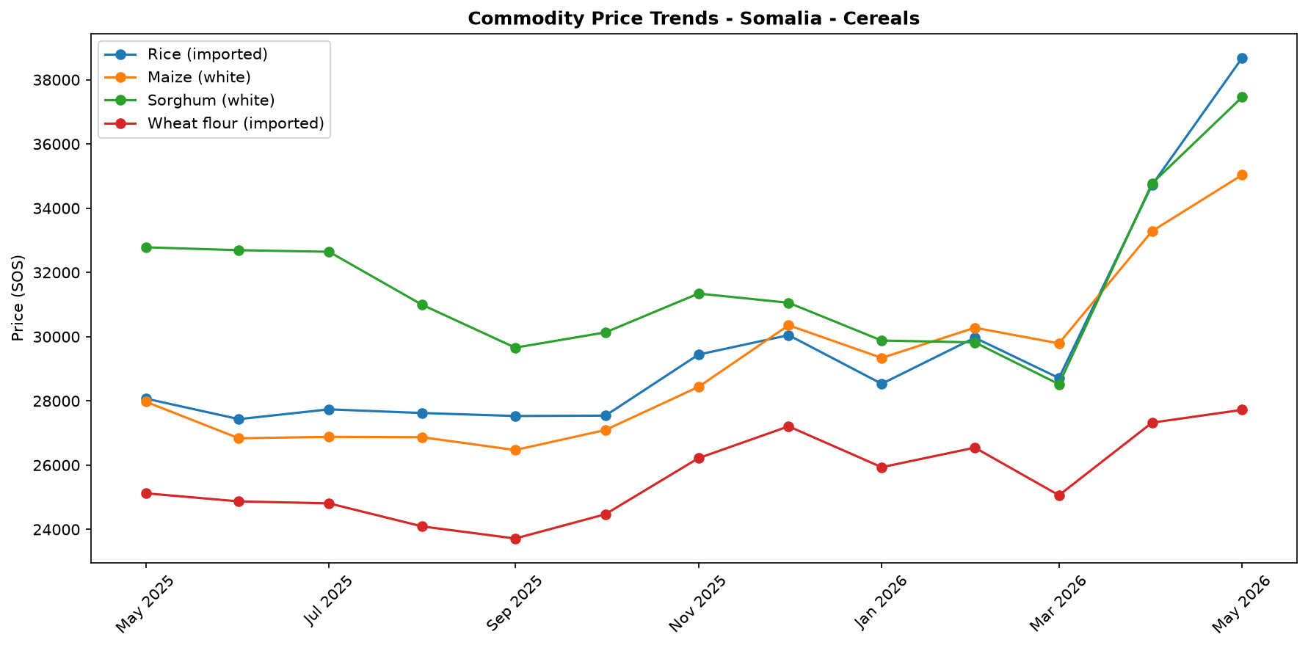
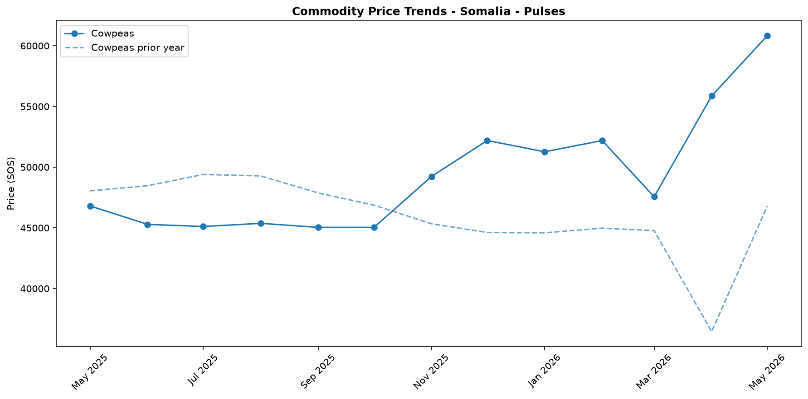
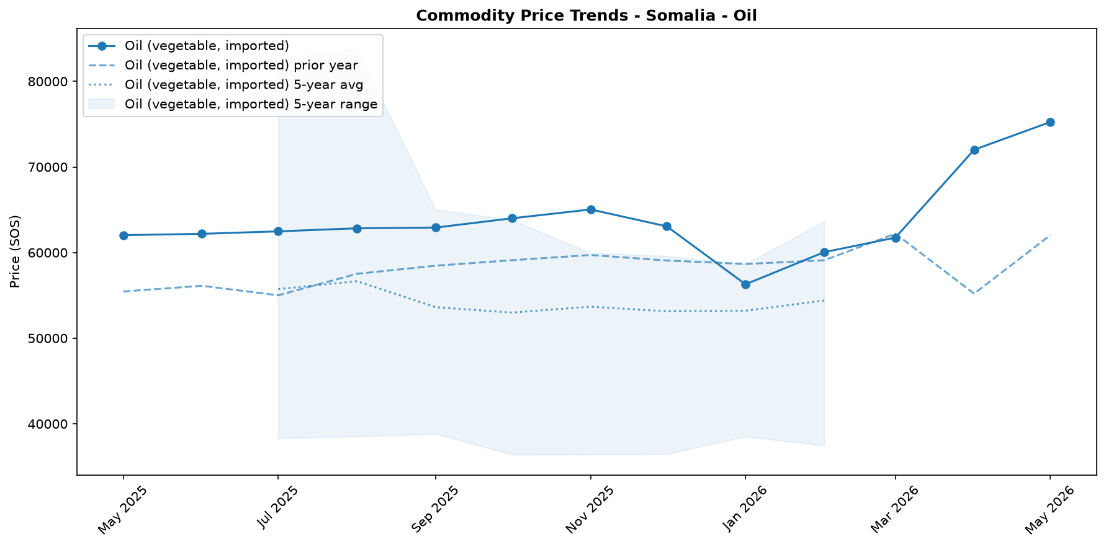
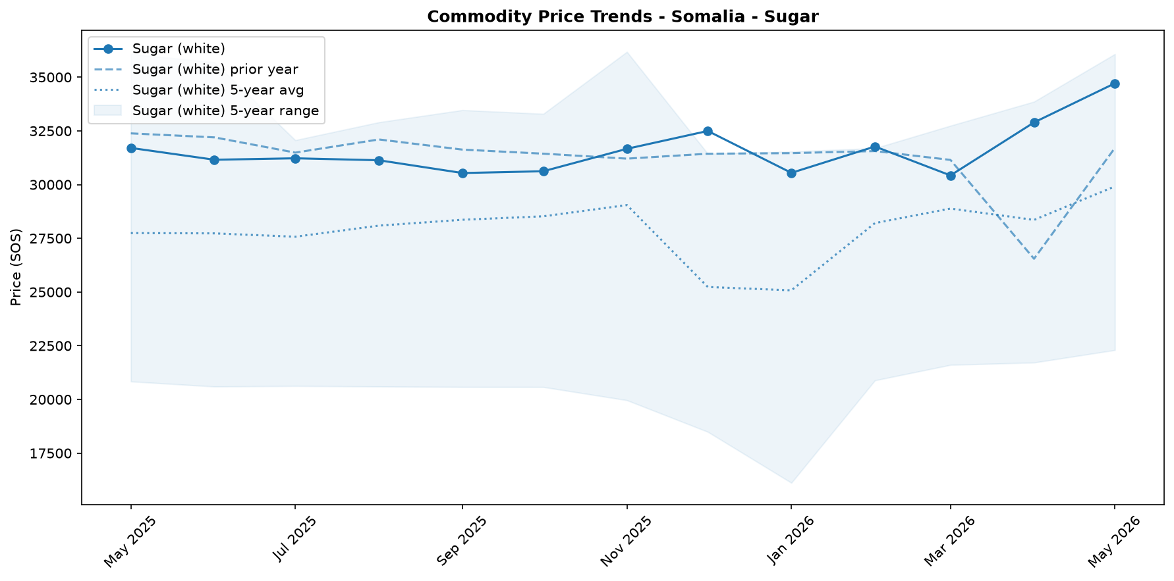

Regional Highlights
May's data reveals extreme regional price disparities, underscoring severe market fragmentation and the impact of localized shocks, insecurity, and logistical bottlenecks. The price spread between the highest and lowest-priced regions reached 111.1 percent for diesel and an immense 161.0 percent for a live goat, indicating that goods are not flowing freely across the country.
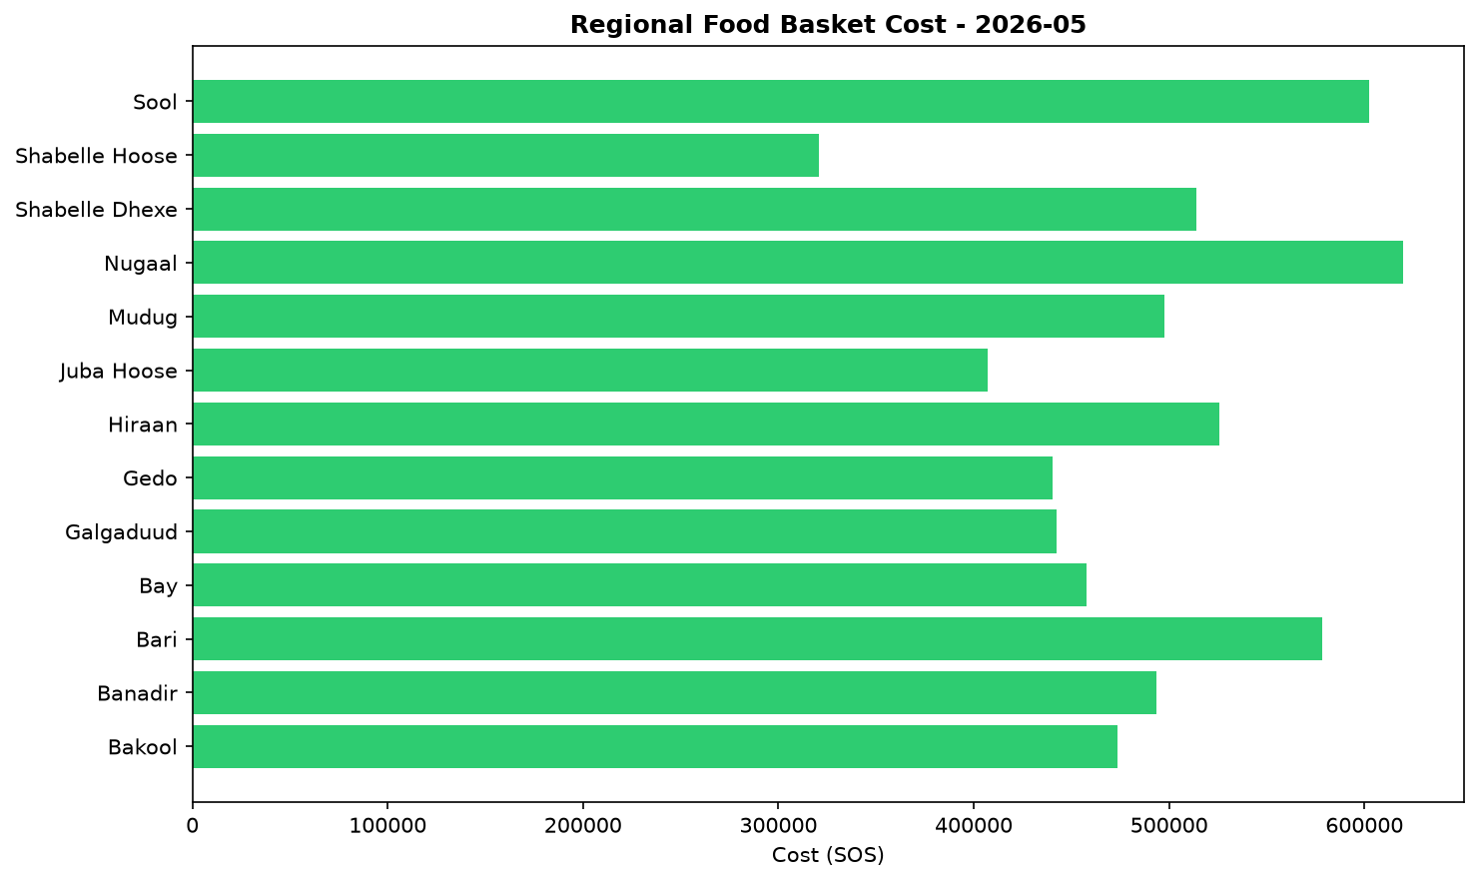
This fragmentation is starkly illustrated by the contrasting conditions in the Bakool and Sool regions. Bakool recorded the nation's highest diesel prices, which likely impedes the transport of goods out of the region. Concurrently, it had the country's lowest prices for live goats and goat meat, suggesting a localized surplus where producers cannot access more profitable markets. In sharp contrast, Sool registered the highest prices for both live goats and goat meat. The price for a live goat in Sool was over 2.5 times higher than in Bakool, pointing to either extreme local demand, severe supply shortages, or prohibitive costs associated with bringing livestock to market in the region. These variations create vastly different economic realities and levels of food access for households depending on their location.

Exchange Rate Analysis
The Somali Shilling (SOS) remained stable against the US dollar, trading at an average of 571.5 SOS per USD. The exchange rate recorded a 0.0 percent change compared to the previous month, indicating continued stability that helps prevent an increase in the cost of imported goods due to currency fluctuations. On a year-on-year basis, the rate also showed no change, highlighting a prolonged period of steadiness that provides a predictable environment for international trade. This sustained stability is crucial for food security, as it helps to contain domestic price increases for key imported commodities like wheat, rice, cooking oil, and fuel. While global market dynamics can still influence local prices, the lack of currency depreciation means the exchange rate is not currently an additional driver of food price inflation in Somalia.

Fuel & Energy
The national average retail price of diesel was SOS 48,430 per litre in May 2026, remaining nearly stable month-on-month (+0.1 percent) but 48.3 percent higher year-on-year. This minimal monthly change is consistent with broadly stable fuel-market or administered pricing conditions. Nevertheless, the high annual price level establishes an elevated cost base for transportation, which is a likely contributor to the widespread year-on-year inflation observed across the food basket, with significant market fragmentation persisting as diesel prices in the highest-priced region were more than double those in the lowest.
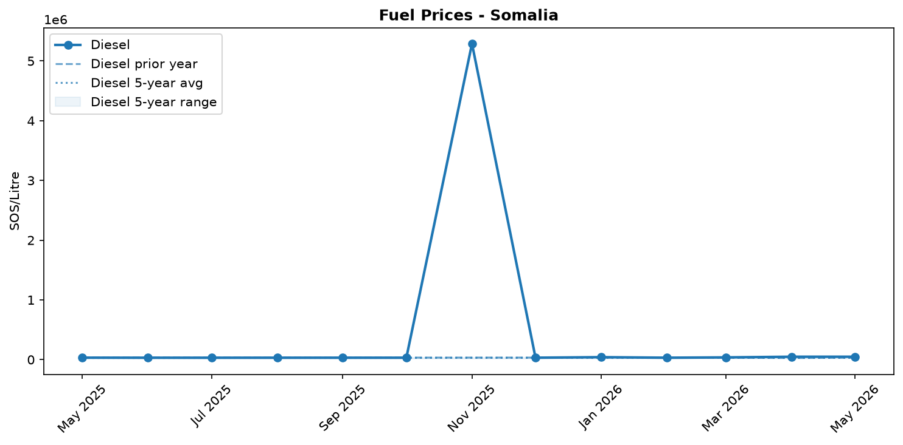
Fuel retail price trend

Livestock & Animal Products
In May, the price of a live goat surged by 26.7 percent to SOS 4,043,689 per head, while goat meat rose 14.4 percent to SOS 281,711 per kg and camel milk increased slightly to SOS 53,006 per liter. These significant price increases are consistent with widespread inflation and high transport costs, and are likely exacerbated by pressures on feed, pasture, and water. While the sharp rise in live goat prices may improve pastoralist incomes, the corresponding increase in meat and milk prices is straining household budgets and reducing the affordability of essential animal-source proteins. This trend is compounded by severe market fragmentation, with the price of a live goat in the Sool region being 161 percent higher than in the Bakool region.
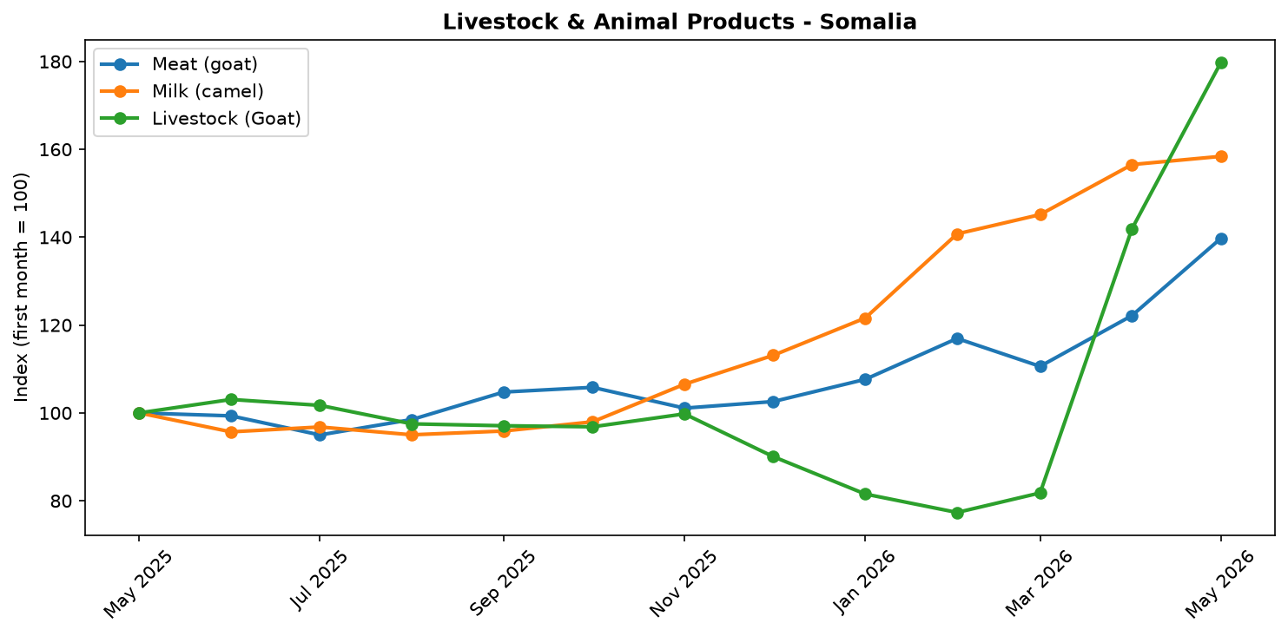
Livestock and animal product price trend

References
- [rw_4214041] ReliefWeb (2026-05-29) Somali Cash Consortium – Baseline and Endline Findings MPCA Outcomes from the Direct Nutrition Referral Approach: Gedo & Banadir regions, Somalia (November 2025)
https://reliefweb.int/node/4214041
- [rw_4213907] ReliefWeb (2026-05-28) Somalia: Emergency and Resilience Plan, 2026–2028
https://reliefweb.int/node/4213907
- [rw_4213862] ReliefWeb (2026-05-28) World Hunger Day: Urgent global action needed as hunger doubles in a decade
https://reliefweb.int/node/4213862
- [rw_4213744] ReliefWeb (2026-05-26) Somalia Faces Deepening Hunger Crisis as Risk of Famine Emerges in Burhakaba
https://reliefweb.int/node/4213744
- [rw_4213683] ReliefWeb (2026-05-26) Somalia: Diphtheria Outbreak - DREF Final Report (MDRSO024)
https://reliefweb.int/node/4213683
- [rw_4213549] ReliefWeb (2026-05-25) WFP Somalia Country Brief May 2026
https://reliefweb.int/node/4213549
- [rw_4213533] ReliefWeb (2026-05-25) Sexual Exploitation and Abuse (SEA) Joint Risk Assessment for Somalia - February 2025
https://reliefweb.int/node/4213533
- [rw_4213456] ReliefWeb (2026-05-25) Somalia Weekly Weather Forecast - Valid From 21 to 27 May 2026
https://reliefweb.int/node/4213456
- [rw_4213396] ReliefWeb (2026-05-24) Somalia - ARC Drought Insurance Payout Activation Bulletin: 2025–26 Deyr Season (May 2026)
https://reliefweb.int/node/4213396
- [rw_4213288] ReliefWeb (2026-05-22) Radio Ergo Weekly Feedback Report, Issued: 22 May 2026
https://reliefweb.int/node/4213288
- [seerist_1028776] Seerist (2026-05-29) Global maritime outlook: June 2026
- [seerist_1028721] Seerist (2026-05-27) Big Picture series: Carbon markets in Sub-Saharan Africa – growing opportunities amid regulatory, integrity challenges
- [seerist_1028607] Seerist (2026-05-19) Big Picture series: France’s push into anglophone Africa to bring new commercial opportunities despite West African controversies
- [seerist_1028580] Seerist (2026-05-18) Substantial ransoms to remain feature of Somali piracy following reported USD 10m demand
- [seerist_1028391] Seerist (2026-04-30) Global maritime outlook: May 2026
- [seerist_1028308] Seerist (2026-04-24) Local resistance, external pressure likely to undermine federal push to remove Jubaland administration
- [seerist_1028144] Seerist (2026-04-14) Big Picture series: Strait of Hormuz disruption to drive acute fiscal, supply chain challenges in Africa

